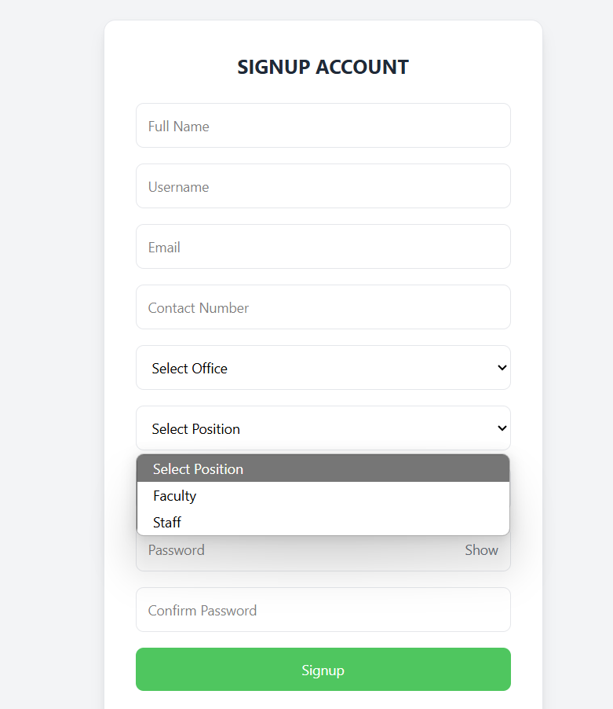
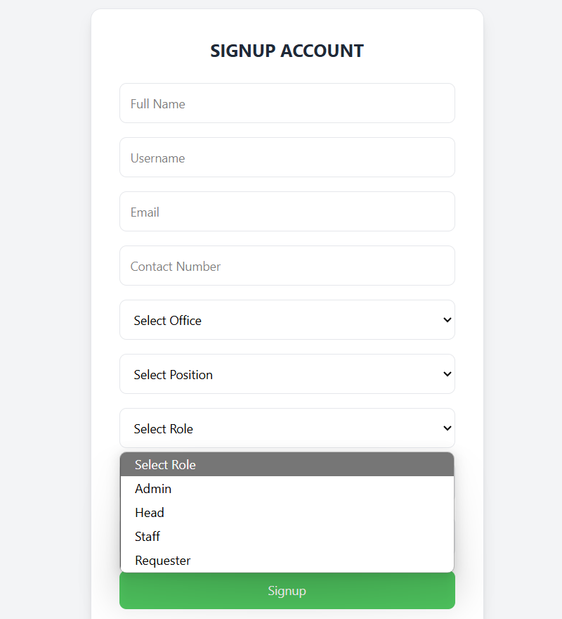
1.Bug Report / Feature Request: Dynamic Role and Position Based on Office Selection
There are two related issues regarding how the Select Position and Select Role dropdowns behave based on the selected Office:
1. If the selected office is "GSO":
- The Select Position field should be disabled or cleared, since GSO users do not need to select a client position like Faculty or Staff.
- The Select Role should remain user-defined (Admin, Head, Staff, etc.).
2. If the selected office is NOT "GSO":
- The Select Position dropdown should remain active.
- The Select Role should automatically be set to "Requester", since clients (non-GSO) should only have that role.
Expected Behavior Summary:
Condition | Select Position | Select Role
Office = GSO | Disabled/cleared | User selects
Office ≠ GSO | Active | Auto-set to "Requester"
2.Bug Report: Incorrect User Details Displayed During Review
Description:
When a head user attempts to review individual account requests, the system displays the details of the most recent requester regardless of which user is selected. For example, if Brenda is the last to request, her information appears when reviewing Jerome or Rald.

Steps to Reproduce:
- Navigate to the Admin > User Requests page.
- Observe multiple pending user requests (e.g., Brenda, Jerome, Rald).
- Click the Review button beside Jerome or Rald.
- Notice that the details shown are for Brenda (the last requester), not the selected user.
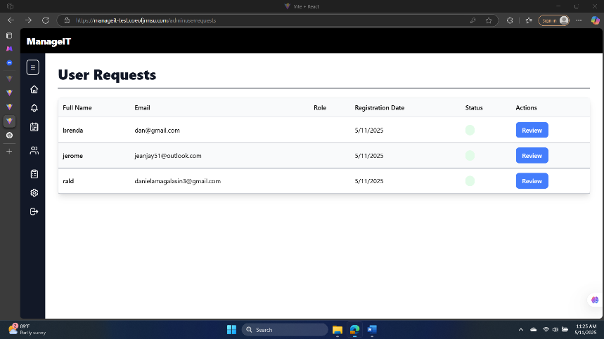
Expected Behavior:
Each time the Review button is clicked, the system should display the correct information corresponding to the selected user — including full name, email, role, and registration date.

3.Bug Report: Failed to Update Status on Approve/Disapprove
Description:
As an admin, I am responsible for approving or disapproving user account requests. However, when I attempt to approve or disapprove a request, the system shows an error message:
"Failed to update status", even though I expect the status to change accordingly.
Steps to Reproduce:
- Go to the Admin > User Requests page.
- Click Review beside any pending user.
- In the review panel, click Approve or Disapprove.
- Observe the system response.
- A message saying "Failed to update status" appears, and the user's status does not change.
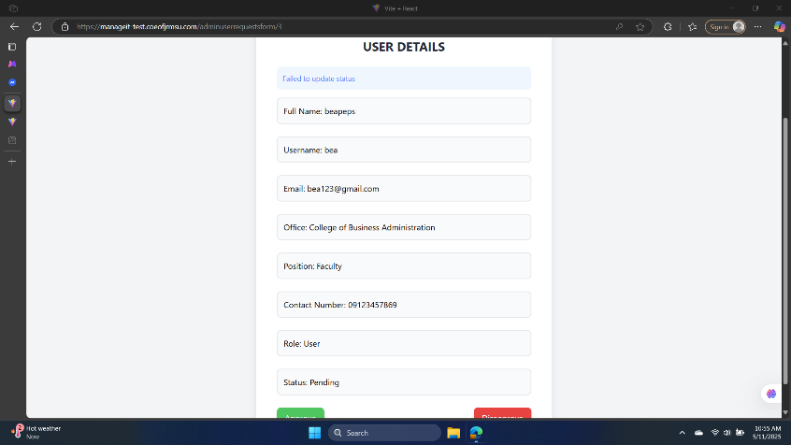
Expected Behavior:
Upon clicking Approve or Disapprove, the system should:
- Successfully update the user's status in the database.
- Reflect the new status (approved/disapproved) in the UI.
- Optionally, show a success message like "Status updated successfully".

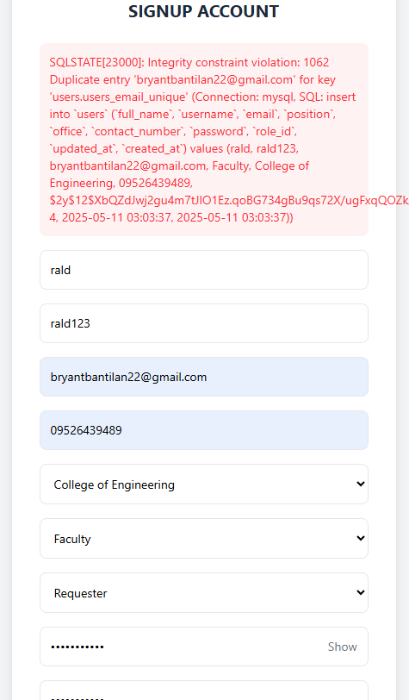
4. when I create account when the same gmail that exist this error pop up

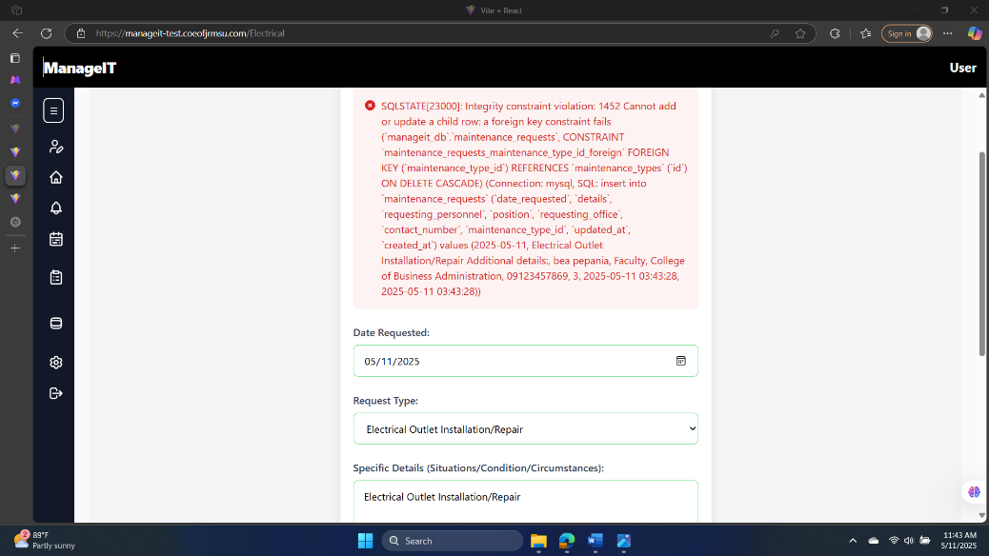
5.As a user when I request this error pop up when I submit my request
6. as a admin this error pop up when I submit my request
SQLSTATE[23000]: Integrity constraint violation: 1452 Cannot add or update a child row: a foreign key constraint fails (`manageit_db`.`maintenance_requests`, CONSTRAINT `maintenance_requests_maintenance_type_id_foreign` FOREIGN KEY (`maintenance_type_id`) REFERENCES `maintenance_types` (`id`) ON DELETE CASCADE) (Connection: mysql, SQL: insert into `maintenance_requests` (`date_requested`, `details`, `requesting_personnel`, `position`, `requesting_office`, `contact_number`, `maintenance_type_id`, `updated_at`, `created_at`) values (2025-05-11, xdtydh, Admin User, Administrator, GSO, 09123456789, 1, 2025-05-11 13:27:36, 2025-05-11 13:27:36))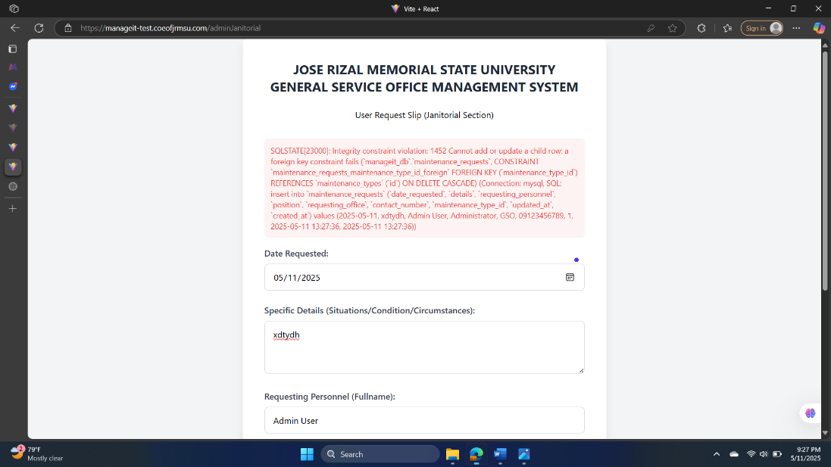\
- as a staff when I request I have the same error with user,admin, and head

